

Principles of Machine Learning

Lab 6 – Unsupervised Learning

# Overview

In this lab, you will use Azure Machine Learning to build unsupervised learning models. Up until now in this course, you have been working with supervised machine learning models. Supervised machine learning models are trained using known labels. In contrast, unsupervised learning models do not require labels. However, the lack of labels makes evaluation of unsupervised learning models more challenging and less objective.

First, you will create a K-Means clustering model that clusters adults based on census information. Then you will create another unsupervised learning model, a recommender for a movie service.

# What You’ll Need

To complete this lab, you will need the following:

* An Azure ML account
* A web browser and Internet connection
* The files for this lab

**Note**: To set up the required environment for the lab, follow the instructions in the [Setup Guide](https://aka.ms/edx-dat203.2x-setup) for this course. Then download and extract the lab files for this lab.

# Creating a Clustering Model

In this exercise you will perform k-means cluster analysis on the Adult Census Income Binary Classification Dataset. You will determine how many natural clusters these data contain and evaluate which features define this structure.

## Prepare the Data

The source data for the classification model you will create is provided as a sample dataset in Azure ML. before you can use it to train a classification model you must prepare the data using some of the techniques you have learned previously in this course.

1. Open a browser and browse to <https://studio.azureml.net>. Then sign in using the Microsoft account associated with your Azure ML account.
2. Create a new blank experiment and name it **Adult Income Clustering**.
3. In the **Adult Income Clustering** experiment, drag the **Adult Census Income Binary Classification** sample dataset to the canvas.
4. Visualize the output of the dataset, and review the data it contains. Note that the dataset contains the following variables:
   * **age**: A numeric feature representing the age of the census respondent.
   * **workclass**: A string feature representing the type of employment of the census respondent.
   * **fnlwgt**: A numeric feature representing the weighting of this record from the census sample when applied to the total population.
   * **education**: A string feature representing the highest level of education attained by the census respondent.
   * **education-num**: A numeric feature representing the highest level of education attained by the census respondent.
   * **marital-status**: A string feature indicating the marital status of the census respondent.
   * **occupation**: A string feature representing the occupation of the census respondent.
   * **relationship**: A categorical feature indicating the family relationship role of the census respondent.
   * **race**: A string feature indicating the ethnicity of the census respondent.
   * **sex**: A categorical feature indicating the gender of the census respondent.
   * **capital-gain**: A numeric feature indicating the capital gains realized by the census respondent.
   * **capital-loss**: A numeric feature indicating the capital losses incurred by the census respondent.
   * **hours-per-week**: A numeric feature indicating the number of hours worked per week by the census respondent.
   * **native-country**: A string feature indicating the nationality of the census respondent.
   * **income**: A label indicating whether the census respondent earns $50,000 or less, or more than $50,000.
5. Add a **Select Columns in Dataset** module to the experiment, and connect the output of the dataset to its input.
6. Select the **Select Columns in Dataset** module, and in the **Properties** pane launch the column selector. Then use the column selector to exclude the following columns:
   * education
   * fnlwgt
   * capital-gain
   * capital-loss
   * income

You can use the **With Rules** page of the column selector to accomplish this as shown here:

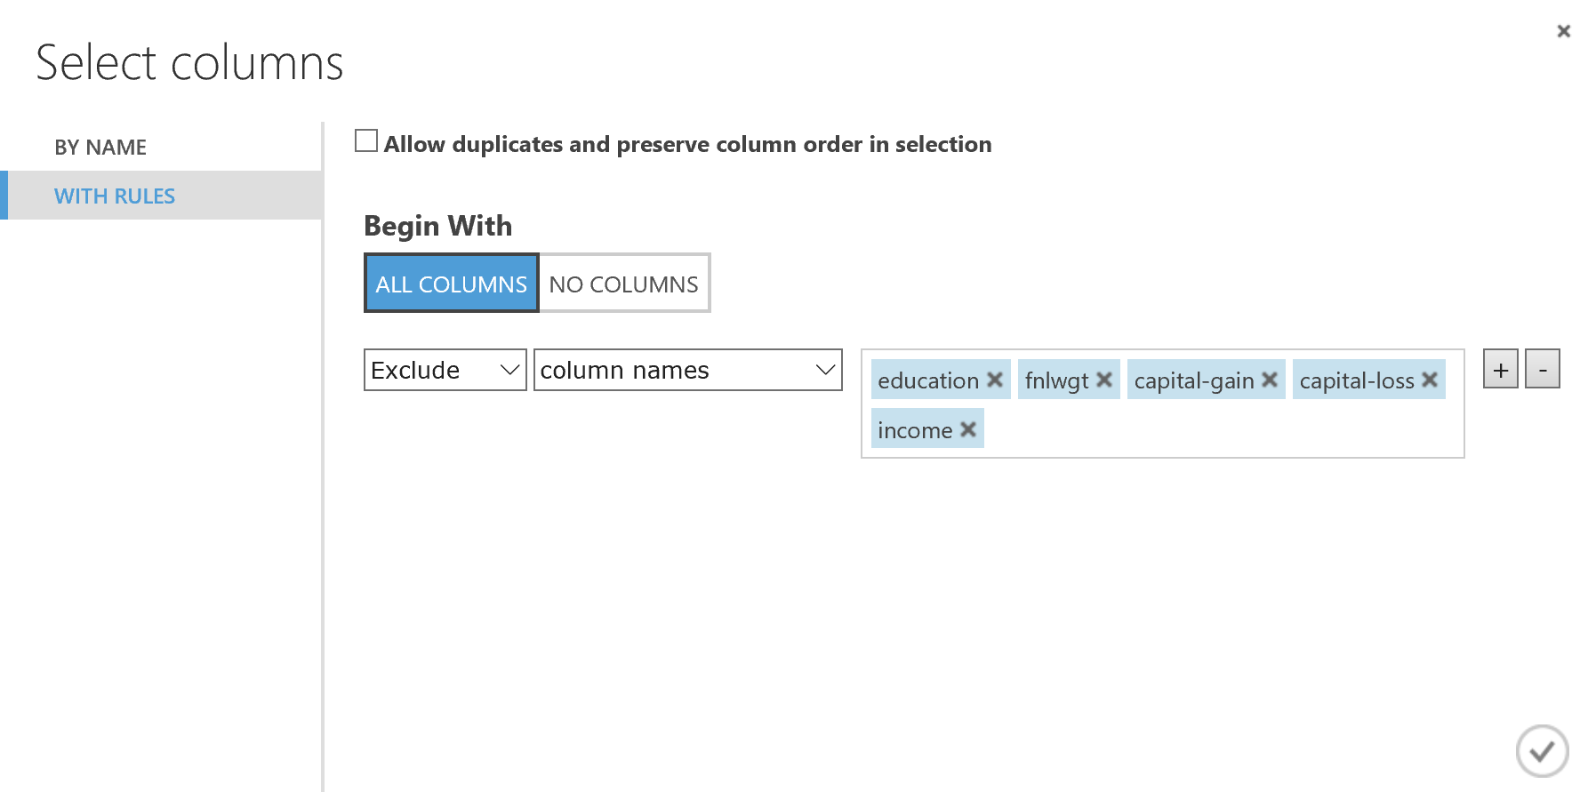

1. Add a **Normalize Data** module to the experiment and connect the output of the **Select Columns in Dataset** module to its input.
2. Set the properties of the **Normalize Data** module as follows:
   * **Transformation method**: MinMax
   * **Use 0 for constant columns**: Unselected
   * **Columns to transform**: All numeric columns
3. Add an **Edit Metadata** module to the experiment, and connect the **Transformed dataset** (left) output of the **Normalize Data** module to its input.
4. Set the properties of the **Edit Metadata** module as follows:
   * **Column**: All string columns
   * **Data type**: Unchanged
   * **Categorical**: Make categorical
   * **Fields**: Unchanged
   * **New column names**: *Leave blank*
5. Verify that your experiment looks like the following, and then save and run the experiment:

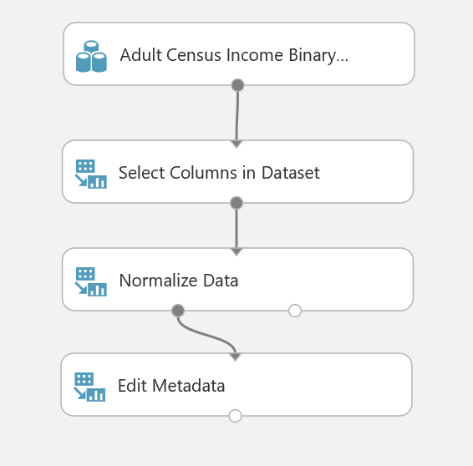

1. When the experiment has finished running, visualize the output of the **Edit Metadata** module and verify that:
   * The columns you specified have been removed.
   * All numeric columns now contain a scaled value between 0 and 1.
   * All string columns now have a **Feature Type** of *Categorical Feature*.

## Determine the Optimal Number of Clusters

Now that the data is prepared, you are ready to use K-Means clustering to separate the data out into clusters. Before doing this, you should spend some time determining the optimal K value – in other words how many clusters the data can be clearly separated into.

1. Add a **K-Means Clustering** module to the **Adult Income Clustering** experiment, and set its properties as follows:
   * **Create trainer mode**: Parameter Range
   * **Range for number of Centroids**: 2, 3, 4, 5
   * **Initialization for sweep**: K-Means ++
   * **Random number seed**: 123
   * **Number of seeds to sweep**: 10
   * **Metric**: Euclidian
   * **Iterations**: 100
   * **Assign Label Model**: Ignore label column
2. Add a **Sweep Clustering** module to the experiment, and connect the output of the **K-Means Clustering** module to its **Untrained model** (left) input and the output of the **Edit Metadata** module to its **Dataset** (right) input.
3. Configure the properties of the **Sweep Clustering** module as follows:
   * **Metric for measuring cluster result**: Average Deviation
   * **Specify parameter sweeping mode**: Random sweep
   * **Maximum number of runs on random sweep**: 25
   * **Random seed**: 123
   * **Column set**: Start with no columns and select all numeric columns.
   * **Check for Append or uncheck for Result Only**: Checked
4. Add an **Evaluate Model** module to the experiment, and connect the **Results dataset** (middle) output of the **Sweep Clustering** module to its input.
5. Verify that the experiment resembles this, and then save and run the experiment.

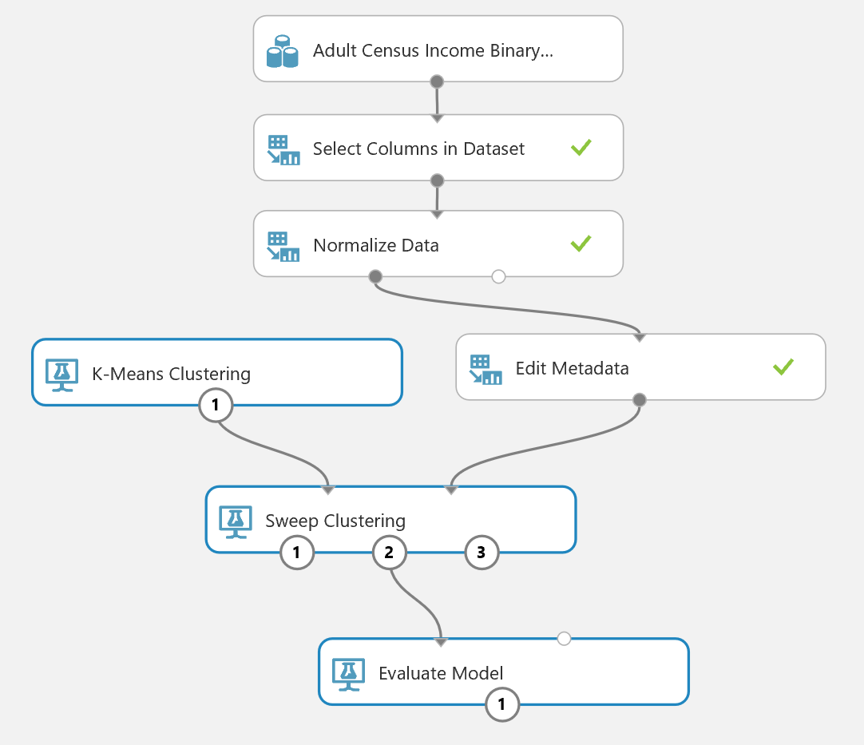

1. When the experiment has finished running, visualize the **Sweep Results** (right-most) output of the **Sweep Clustering** module and review the results. The results with the lowest average deviations are the best clusters, so it looks like the optimal number of centroids for this data is five.
2. Visualize the **Results** (middle) output of the **Sweep Clustering** module, which shows the cluster assignments for the best performing model. Note that each row has an **Assignment** column indicating to which of the five clusters the point represented by this row is assigned, and metrics that show the distance to the center of each cluster. The row is assigned to the cluster to which it is closest, but in some cases this may be a marginal difference.
3. Visualize the output of the **Evaluate Model** module, and review the details for each cluster. These include the average distance between points in each cluster and its center, and the average distance between to the center of the other clusters. In some cases, the numbers are close, indicating that there may be a degree of overlap in the clusters. The evaluation results also includes the number of points assigned to each cluster.

## Create a K-Means Clustering Model

Now you are ready to create a clustering model using the K value you have determined.

1. Add a **Train Clustering Model** module to the experiment, and connect the **Best Trained model** (left) output of the **Sweep Clustering** module to its **Untrained model** (left) input and the output of the **Edit Metadata** module to its **Dataset** (right) input.
2. Configure the properties of the **Train Clustering Model** module to select all numeric features and enable the **Check for Append or Uncheck for Result Only** option.
3. Verify that the experiment resembles this, and then save and run the experiment.

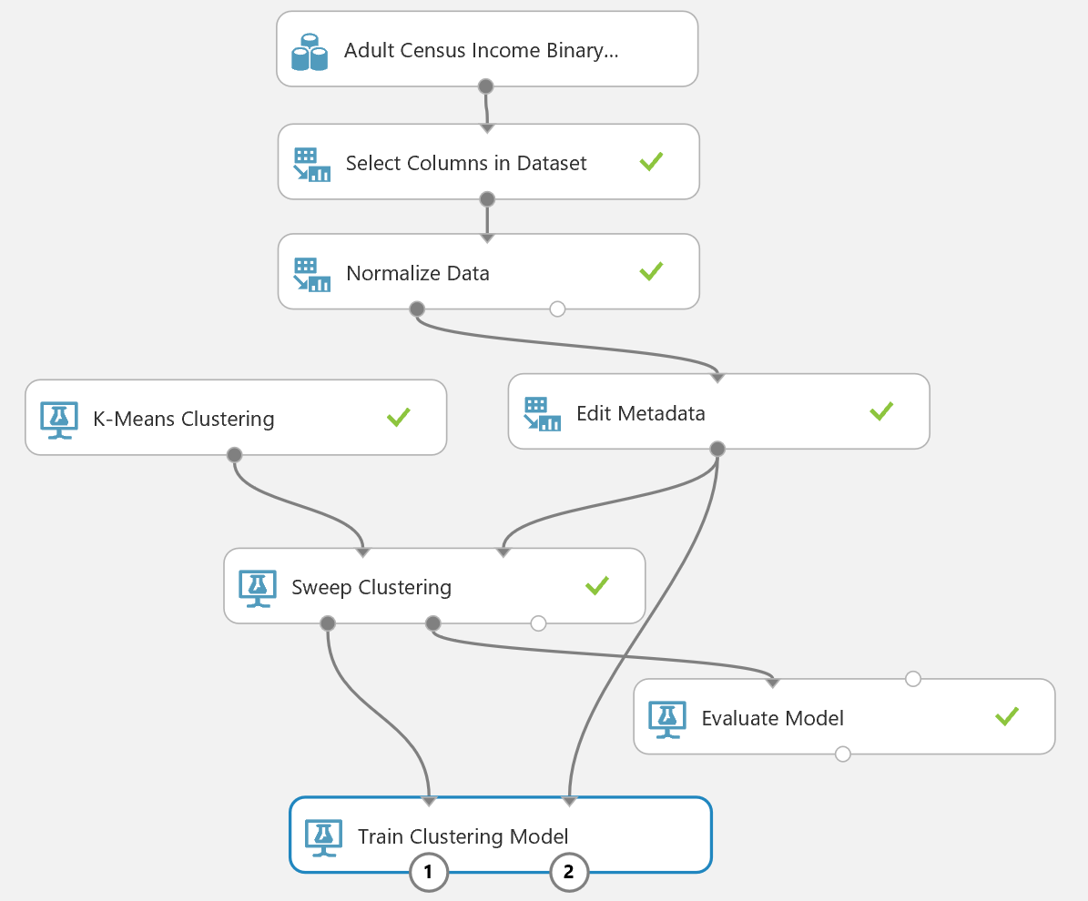

1. When the experiment has finished running, visualize the **Results** (right) output of the **Train Clustering Model** module and note the visualization that shows the five clusters that have been generated.

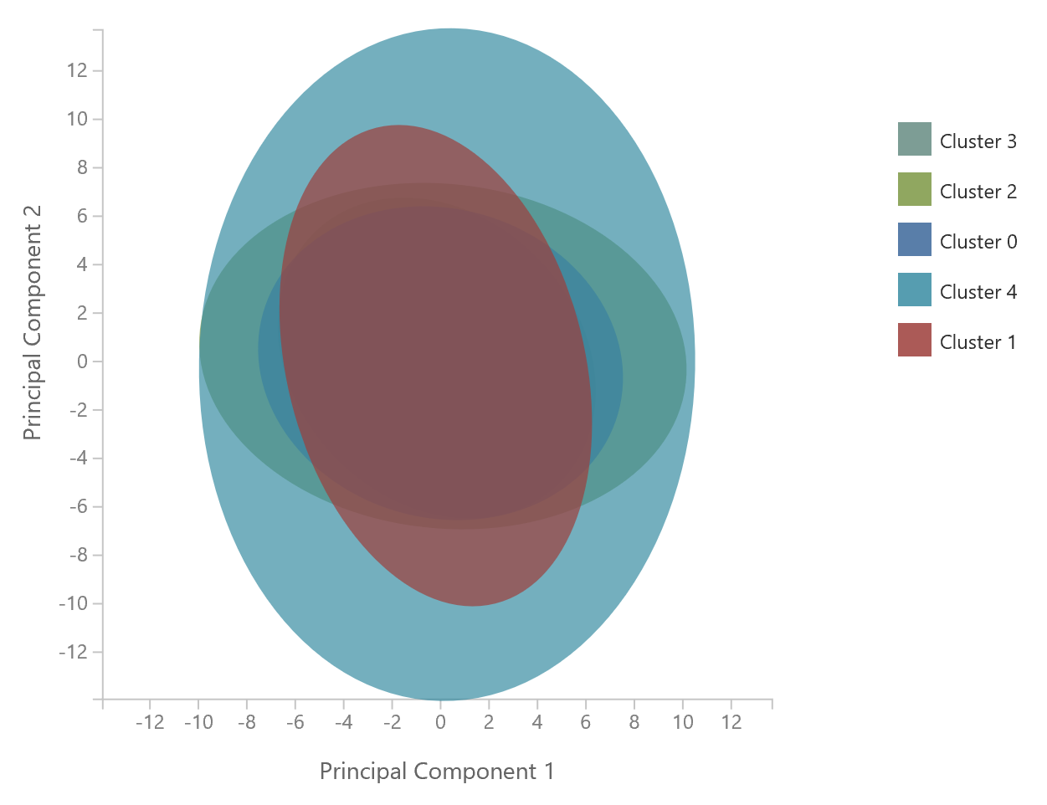

Note that each of the clusters is represented by an ellipse in this principle component projection. The axes of the ellipses point in different directions, which is an indication of the separation between the clusters. Notice that the major (long) axis of the ellipse for cluster 2 is almost perpendicular to the major axes for cluster 4. However, the major axes of the ellipse for clusters 0 and 2 and for clusters 1 and 4 are nearly aligned, indicating a fair degree of overlap.

## Publish the Model as a Web Service

1. Select the **Train Clustering Model** module, and click the **SET UP WEB SERVICE** icon at the bottom of the Azure ML Studio page and click **Predictive Web Service [Recommended]**. A new **Predictive Experiment** tab will be automatically created.
2. Verify that, with a bit of rearranging, the Predictive Experiment resembles this figure:

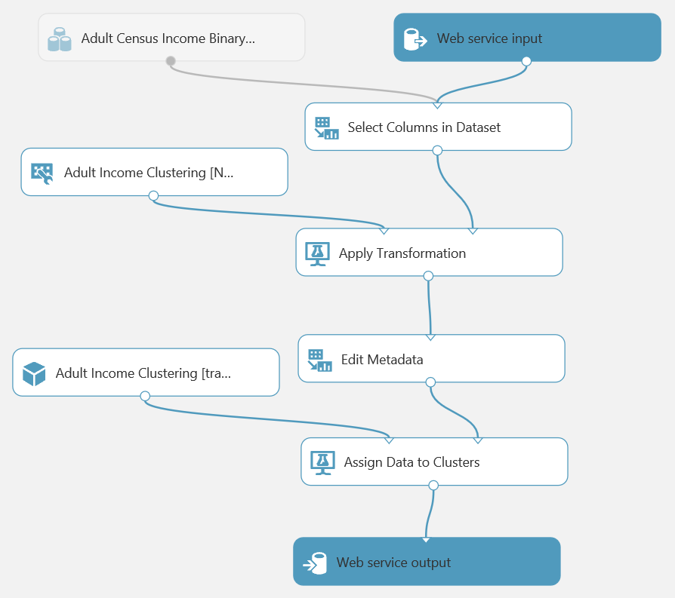

1. Run the predictive experiment, and view the output from the **Assign Data to Clusters** module, verifying that it shows the PCA diagram you viewed previously.
2. Add a **Select Columns in Dataset** module to the experiment, and connect the output of the **Assign Data to Clusters** module to its input. Then connect the output of the **Select Columns in Dataset** module to the input of the **Web service output** module (this replaces the existing connection from the **Assign Data to Clusters** module)
3. Select the **Select Columns in Dataset** module, and use the column selector to select only the **Assignments** column.
4. Ensure that the predictive experiment now looks like the following, and then save and run the predictive experiment:

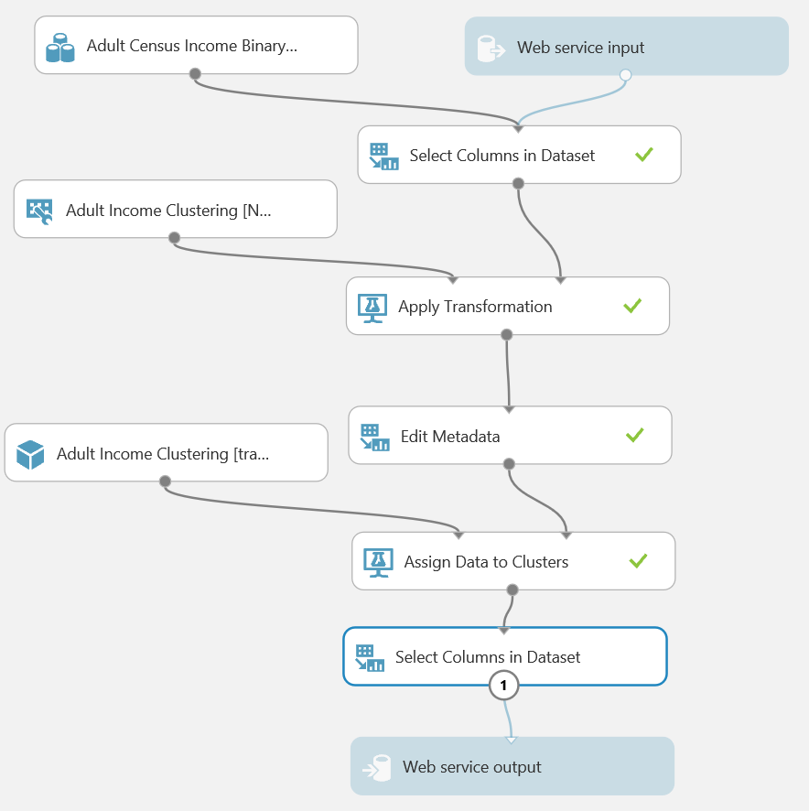

1. When the experiment has finished running, visualize the output of the last **Select Columns in Dataset** module and verify that only the **Assignments** column is returned.

## Deploy and Use the Web Service

1. In the **Adult Income Clustering [Predictive Exp.]** experiment, click the **Deploy Web Service** icon at the bottom of the Azure ML Studio window.
2. Wait a few seconds for the dashboard page to appear, and note the **API key** and **Request/Response** link. You will use these to connect to the web service from a client application.

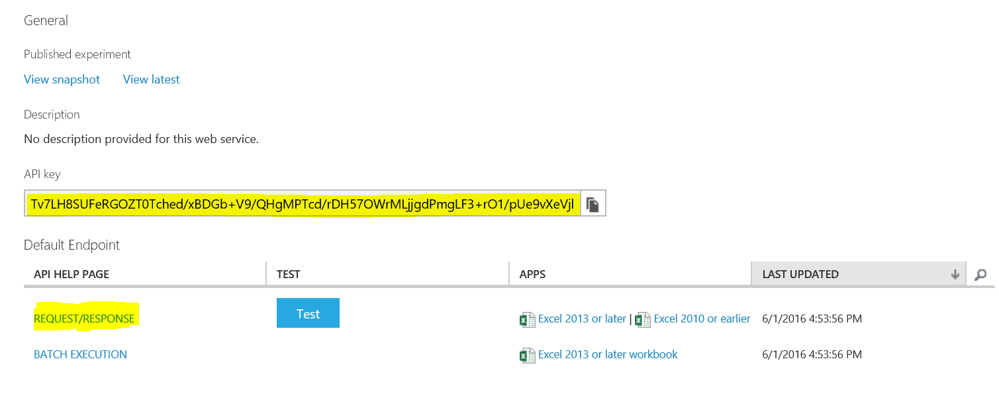

1. Leave the dashboard page open in your web browser, and open a new browser tab.
2. In the new browser tab, navigate to <https://office.live.com/start/Excel.aspx>. If prompted, sign in with your Microsoft account (use the same credentials you use to access Azure ML Studio.)
3. In Excel Online, create a new blank workbook.
4. On the **Insert** tab, click **Office Add-ins**. Then in the **Office Add-ins** dialog box, select **Store**, search for *Azure Machine Learning*, and add the **Azure Machine Learning** add-in as shown below:

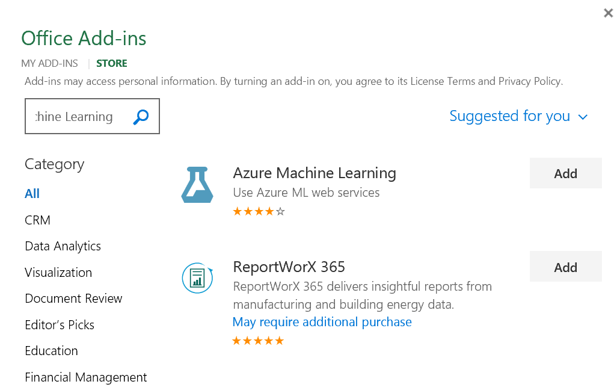

1. After the add-in is installed, in the **Azure Machine Learning** pane on the right of the Excel workbook, click **Add Web Service**. Boxes for the URL and API key of the web service will appear.
2. On the browser tab containing the dashboard page for your Azure ML web service, right-click the **Request/Response** link you noted earlier and copy the web service URL to the clipboard. Then return to the browser tab containing the Excel Online workbook and paste the URL into the URL box.
3. On the browser tab containing the dashboard page for your Azure ML web service, click the **Copy** button for the **API key** you noted earlier to copy the key to the clipboard. Then return to the browser tab containing the Excel Online workbook and paste it into the **API key** box.
4. Verify that the **Azure Machine Learning** pane in your workbook now resembles this, and click **Add**:

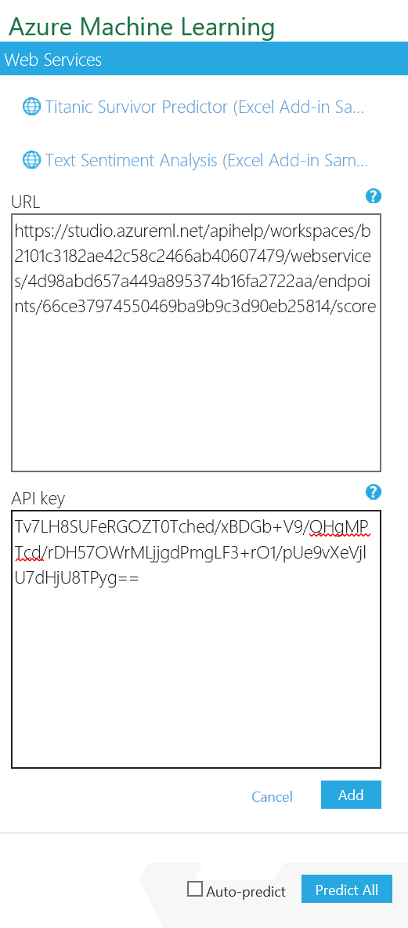

1. After the web service has been added, in the **Azure Machine Learning** pane, click **1. View Schema** and note the *inputs* expected by the web service (which consist of the fields in the original Adult Census dataset) and the *outputs* returned by the web service (the fields you selected in the predictive experiment).
2. In the Excel worksheet select cell A1. Then in the **Azure Machine Learning** pane, collapse the **1. View Schema** section and in the **2. Predict** section, click **Use sample data**. this enters some sample input values in the worksheet.
3. Modify the sample data in row 2 as follows:
   * **age**: 39
   * **workclass**: State-gov
   * **fnlwgt**: 0
   * **education**: Bachelors
   * **education-num**: 13
   * **marital-status**: Never-married
   * **occupation**: Adm-clerical
   * **relationship**: Not-in-family
   * **race**: White
   * **sex**: Female
   * **capital-gain**: 2200
   * **capital-loss**: 0
   * **hours-per-week**: 40
   * **native-country**: United-States
   * **income**: <=50
4. Add a second row of data with the following values:
   * **age**: 50
   * **workclass**: Self-emp-no
   * **fnlwgt**: 0
   * **education**: Bachelors
   * **education-num**: 13
   * **marital-status**: Married-civ-spouse
   * **occupation**: Exec-managerial
   * **relationship**: Husband
   * **race**: Black
   * **sex**: Male
   * **capital-gain**: 0
   * **capital-loss**: 0
   * **hours-per-week**: 13
   * **native-country**: United-States
   * **income**: >=50
5. Add a third row of data with the following values:
   * **age**: 38
   * **workclass**: Private
   * **fnlwgt**: 0
   * **education**: HS-grad
   * **education-num**: 9
   * **marital-status**: Divorced
   * **occupation**: Handlers-cleaners
   * **relationship**: Not-in-family
   * **race**: White
   * **sex**: Male
   * **capital-gain**: 0
   * **capital-loss**: 0
   * **hours-per-week**: 40
   * **native-country**: United-States
   * **income**: <=50
6. Select the cells containing the input data (cells A1 to O4), and in the **Azure Machine Learning** pane, click the button to select the input range and confirm that it is **‘Sheet1’!A1:O4**.
7. Ensure that the **My data has headers** box is checked.
8. In the **Output** box type **P1**, and ensure the **Include headers** box is checked.
9. Click the **Predict** button, and after a few seconds, note the predicted cluster assignments returned in column P.

# Implementing a Recommender

Recommenders are an interesting and useful class of machine learning models. Creating good recommenders is challenging since there is no objective way to measure how good a recommendation is for a given individual. There is no way to know if the recommendation is the best possible for an individual. Further, the ratings provided by the users, is based on their personal subjective judgement.

In this exercise you will implement a recommender for a movie streaming service. Your solution will recommend up to three movies for a user based on movies they, and other users like them, have previously viewed.

## Create Sample Datasets

The built-in sample dataset for movie recommendations contains over 227,000 reviews. While this is a reasonable number for training a recommender, using this full dataset will result in long model training times when using a free Azure ML account. For expediency, you will therefore extract a 5 % sample of this data for use in this exercise.

1. In Azure ML Studio, create a new experiment called **Movie Sampling**.
2. Search for the **Movie Ratings** dataset and drag it onto the blank canvas.
3. Add a **Partition and Sample** module to the experiment, and connect the output of the **Movie Ratings** dataset to its input. Then set its properties as follows:
   * **Partition or sample mode**: Sampling
   * **Rate of sampling**: 0.05
   * **Random seed for sampling**: 123
   * **Stratified split for sampling**: False
4. Search for the **IMDB Movie Titles** dataset and drag it onto the canvas. This dataset maps numeric movie IDs to human readable movie titles.
5. Search for the **Join** module and drag it onto the canvas.
6. Connect the **Results dataset** output of the **Partition and Sample** module to the **Dataset1** (left) input of the **Join** module.
7. Connect the output of the **IMDB Movie Titles** dataset to the **Dataset2** (right) input of the **Join** module.
8. Configure the properties of the **Join** module as follows:
   * **Column Selector for L** (left): MovieId
   * **Column Selector for R** (right): Movie ID
   * **Match case**: Checked
   * **Join type**: Inner Join
   * **Keep right key column**: Checked
9. Add a **Select Columns in Dataset** module, and connect the output of the **Join Data** module to its input. Then configure it to select only the **Movie ID** and **Movie Name** columns.
10. Add a **Remove Duplicate Rows** module and connect the output of the **Select Columns in Dataset** module to its input. Then configure its properties to select the **Movie ID** and **Movie Name** columns and to retain the first duplicate.
11. Verify that your experiment looks like this:

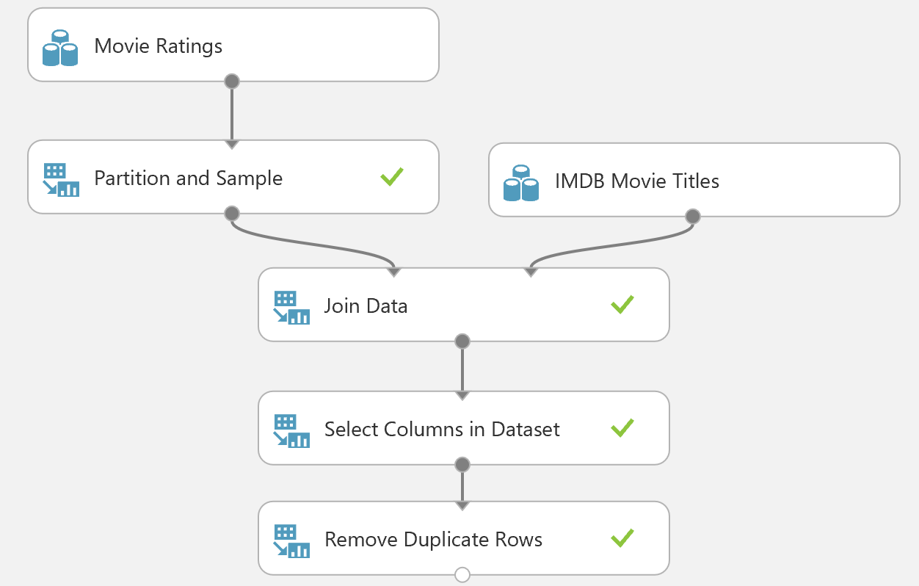

1. Save and run the experiment.
2. When the experiment has finished running, right-click the output of the **Partition and Sample** module and click **Save as Dataset**, and save the dataset as **Movies Sample**, with the description **5% sample of movies**. Then right-click the output of the **Remove Duplicate Rows** module and click **Save as Dataset**, and save the dataset as **IMDB Sample**, with the description **Sample of movie titles**.

## Prepare the Data

Now that you have some sample data, you are ready to prepare it for modeling.

1. In Azure ML Studio, create a new experiment called **Movie Recommendations**.
2. Search for the **Movies Sample** dataset and drag it onto the blank canvas.
3. Search for the **Edit Metadata** module and drag it onto the canvas.
4. Connect the output of the **Movies Sample** dataset to the **Dataset** input of the **Edit Metadata** module.
5. Configure the properties of the **Edit Metadata** module to ensure the **Rating** column is of **Integer** type as required by the **Matchbox Recommender** module:
   * **Column selector**: Rating
   * **Data type**: Integer
   * **Categorical**: Unchanged
   * **Fields**: Unchanged
   * **New column names**: blank
6. Add a **Select Columns in Dataset** module to the experiment and connect the **Results dataset** output of the **Edit Metadata** module to the **Dataset input** of the **Select Columns in Dataset** module.
7. Configure the **Column Selector** of the **Select Columns in Dataset** module. Select the **Allow duplicates and preserve column order in selection** box, and then select the following columns in the order shown below (the order is important):
   * **UserId**
   * **MovieId**
   * **Rating**

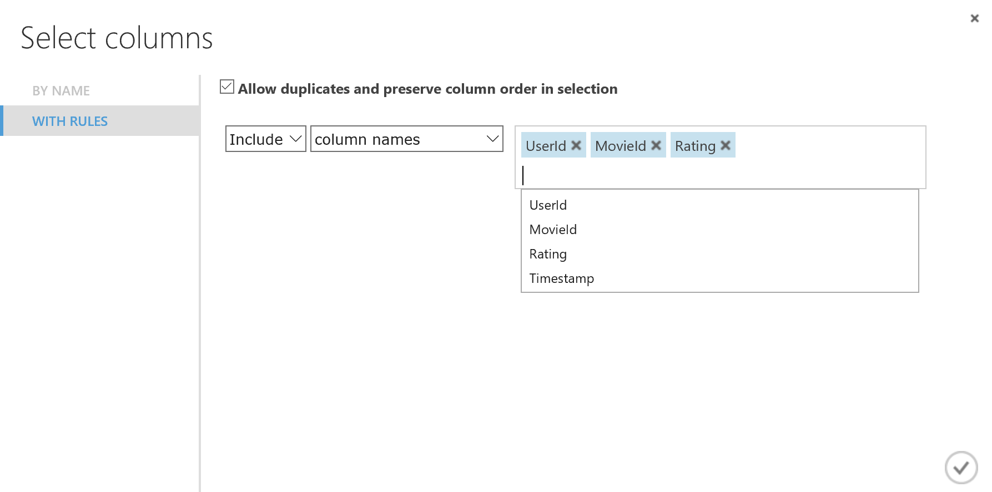

Duplicates are common in rating data. A user may rate the same item multiple times. These duplicates should be removed to prevent them from biasing the results of the recommendation calculation.

1. Add a **Remove Duplicate Rows** module to the experiment and connect the **Results dataset** output of the **Select Columns in Dataset** module to its Then configure the properties of the **Remove Duplicate Rows** module as follows:
   * **Column Selector**: UserId, MovieId
   * **Retain first duplicate row**: checked
2. Verify that your experiment resembles the following figure:

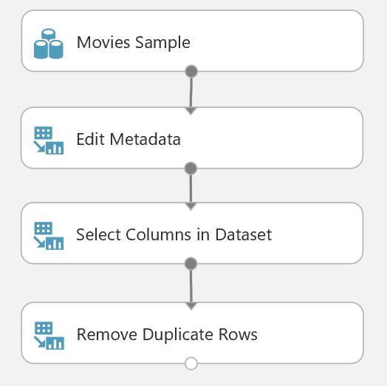

1. Save and run the experiment. When the experiment has finished, visualize the output of the **Remove Duplicate Rows** module. Verify that the results contain around 11,374 rows and 3 columns in the order **UserId**, **MovieId**, **Rating**.

## Train and Score a Recommender

Now that the data is prepared, you can train a recommender.

1. Search for the **Split Data** module and drag it onto the canvas. Then connect the **Results dataset** output of the **Remove Duplicate Rows** module to its input and configure its properties as follows:
   * **Splitting mode**: Recommender Split
   * **Fraction of training-only users**: 0.75
   * **Fraction of test user ratings for training**: 0.25
   * **Fraction of cold users**: 0.1
   * **Fraction of cold items**: 0.1
   * **Fraction of ignored users**: 0
   * **Fraction of ignored items**: 0
   * **Remove occasionally produced cold items**: unchecked
   * **Random seed for Recommender**: 123
2. Search for the **Train Matchbox Recommender** module and drag it onto the canvas. Then connect the **Results dataset1** (left) output of the **Split Data** module to its **Training dataset of user-item-rating triples** (left) input and configure its properties as follows:
   * **Number of traits**: 5
   * **Number of recommendation algorithm iterations**: 5
   * **Number of training batches**: 4
3. Add the **IMDB Sample** dataset to the experiment and connect its output to the **Training dataset of item features** (right-most) input of the **Train Matchbox Recommender** module. This input enables you to add optional additional features for the items you are recommending to help the recommender make better recommendations. In this case, the additional features include only the movie title – better results could be obtained if this dataset included additional information, such as the *director*, *length*, *release year*, or other characteristics of each movie.

**Tip**: You can also use the middle input of the **Train Matchbox Recommender** module to provide additional user features, such as *year of birth*, *place of residence*, *gender*, and so on.

1. Search for the **Score Matchbox Recommender** module and drag it onto the canvas. Then connect the **Trained Matchbox recommender** output of the **Train Matchbox Recommender** module to its **Trained Matchbox recommender** (left) input, connect the **Results dataset2** (right) output of the **Split Data** module to its **Dataset to score** (second from left) input, and connect the output of the **IMDB Sample** dataset to its **Item features** (fourth from left) input.
2. On the properties pane for the **Score Matchbox Recommender** module, ensure that the following properties are specified:
   * **Recommender prediction kind**: Item Recommendation
   * **Recommended item selection**: From Rated Items (for model evaluation)
   * **Maximum number of items to recommend to a user**: 3
   * **Minimum size of the recommendation pool for a single user**: 1
3. Verify that your experiment looks like this:

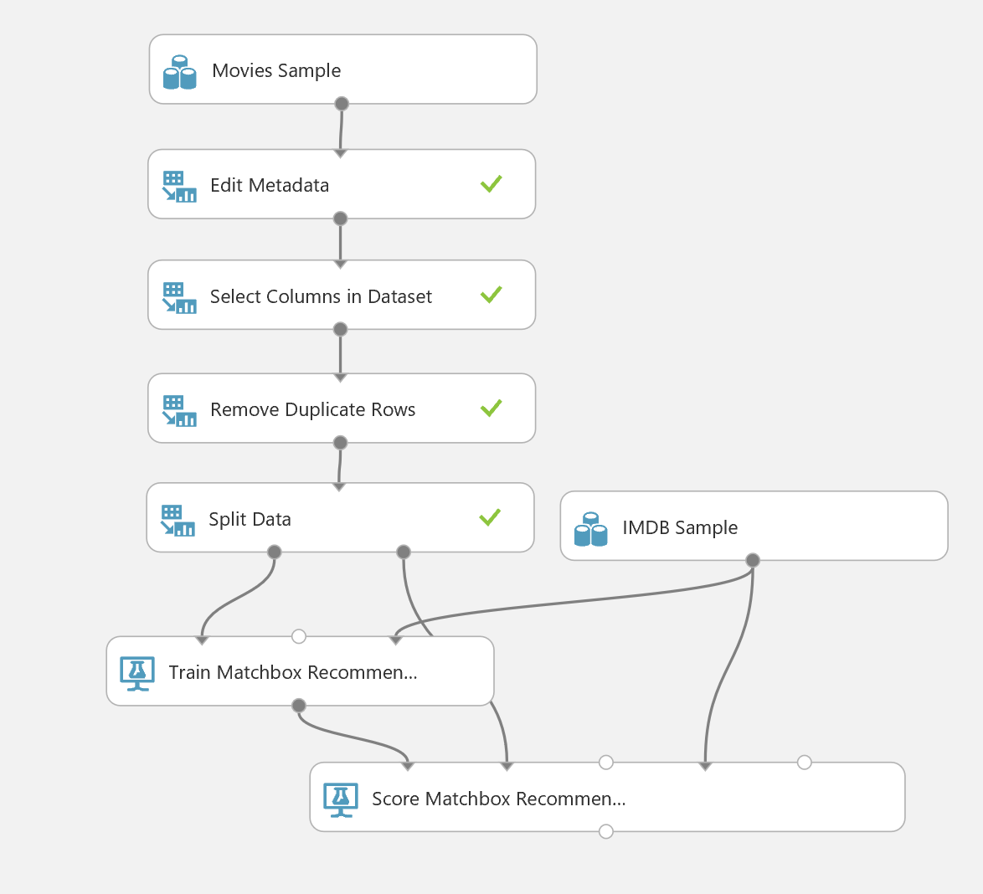

1. Save and run the experiment, and then visualize the output of the **Score Matchbox Recommender** module and view the recommendations made for each user (which consist of up to three movie IDs)

## Evaluate by Item Recommendation

Item Recommendations compute recommendations and evaluate the results using the user’s item ratings. Results are evaluated by averaging normalized discounted cumulative gain (NDCG) over the chosen items. An ideal result has a value of 1.0.

**Note**: Evaluation metrics for other types of recommendations use different metrics. Review the lecture videos and demonstrations in the module to learn more.

1. Search for the **Evaluate Recommender** module and drag it onto the canvas. Then connect the **Results dataset2** (right) output of the **Split Data** module to its **Test dataset** (left) input and connect the **Scored dataset** (right) output of the **Score Matchbox Recommender** module to its **Scored dataset** (right) input.
2. On the properties pane of the **Evaluate Recommender** module, verify that the properties are set as follows:
   * **Minimum number of items that the query user and the related user must have rated in common:** 2
   * **Minimum number of users that the query item and the related item must have been rated by in common:** 2
3. Ensure that you experiment from the **Remove Duplicate Rows** module onwards looks like this:

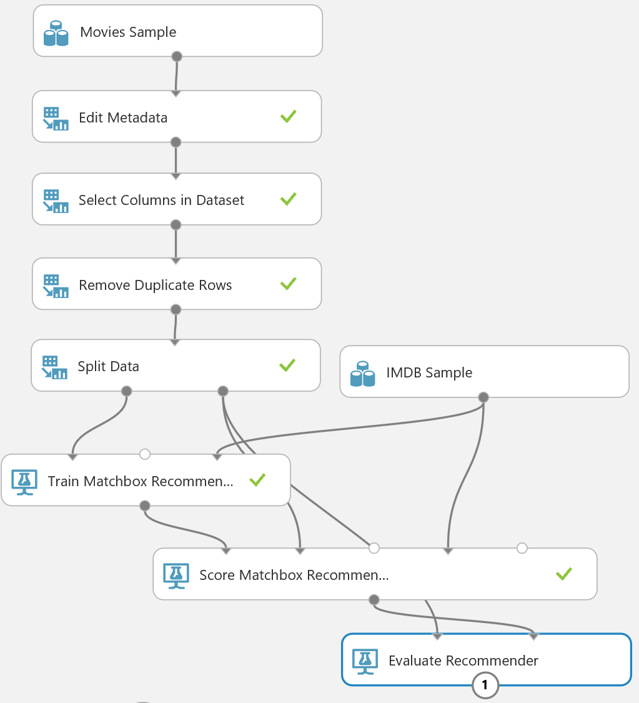

1. Save and run the experiment.

When the experiment has finished, Visualize the output form the **Evaluate Recommender** module. Note that the **NDCG** is about 0.98. This is a good result, not too far from the ideal; but you should note that it is largely helped by the comparatively small sample of data.

## Publish the Model as a Web Service

1. With the **Movie Recommendations** experiment open, click the **SET UP WEB SERVICE** icon at the bottom of the Azure ML Studio page and click **Predictive Web Service [Recommended]**. A new **Predictive Experiment** tab will be automatically created.
2. Verify that, with a bit of rearranging, the Predictive Experiment resembles this figure:

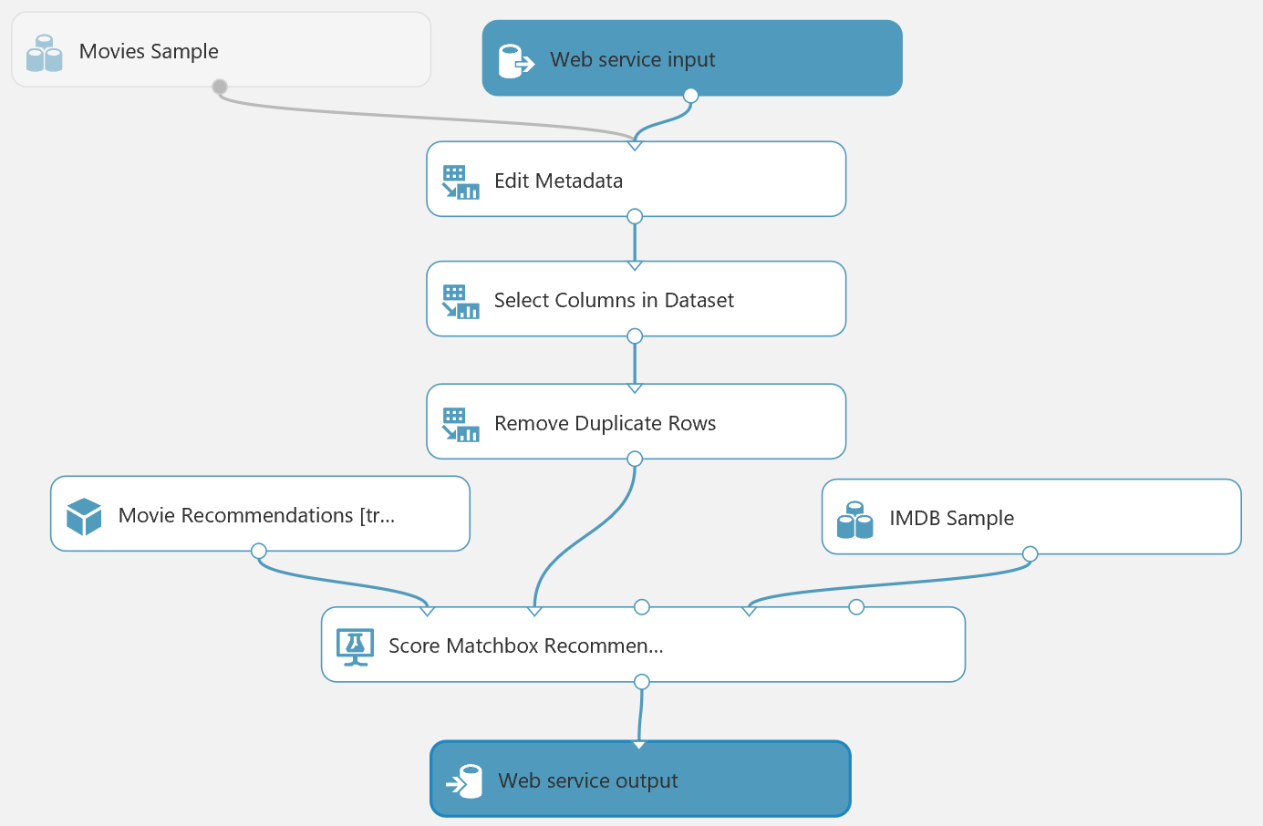

1. Select the **Score Matchbox Recommender** module and change the **Recommended item selection** property from *From Rated Items (for model evaluation)* to *From All Items*, and set the **Maximum number of items to recommend to a user** to 3.

**Note** This step is required to ensure that the model recommends items for new requests instead of recommending items that the user has rated for model evaluation purposes.

1. Run the predictive experiment (this can take a while – over 10 minutes in some cases)
2. When the experiment has finished running, visualize the output from the **Score Matchbox Recommender** module, verifying that it shows three recommendations for each user. However, the recommendations are movie IDs, and the web service will be more useful if it returns movie titles.
3. Add an **Apply SQL Transformation** module to the experiment and drag the output from the **Score Matchbox Recommender** to its **Table1** (left-most) input, and drag the output from the **IMDB Sample** dataset to its **Table2** (middle) input. Then drag the output of the **Apply SQL Transformation** module to the input of the **Web service output** module – this should replace the existing input to this module so that your experiment now looks like this:

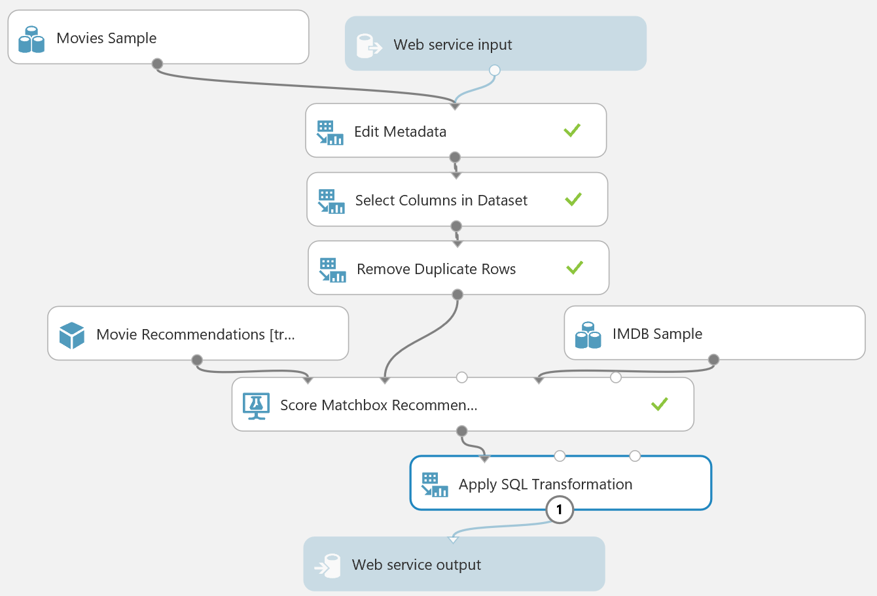

1. Select the **Apply SQL Transformation**, and replace its default SQL script with the following code (which you can copy and paste from **Select Recommended Items.sql** in the lab files folder for this module):

SELECT r1.[Movie Name], r2.[Movie Name], r3.[Movie Name]

FROM t1

JOIN t2 AS r1 ON t1.[Item 1] = r1.[Movie ID]

JOIN t2 AS r2 ON t1.[Item 2] = r2.[Movie ID]

JOIN t2 AS r3 ON t1.[Item 3] = r3.[Movie ID];

1. Save and run the experiment again (it should take less time on this occasion because the predictive model is cached from the previous run). Then visualize the output of the **Apply SQL Transformation** module and verify that the recommended movie titles are returned.

## Deploy and Use the Web Service

1. In the **Movie Recommendations [Predictive Exp.]** experiment, click the **Deploy Web Service** icon at the bottom of the Azure ML Studio window.
2. Wait a few seconds for the dashboard page to appear, and note the **API key** and **Request/Response** link.
3. Create a new blank Excel Online workbook at <https://office.live.com/start/Excel.aspx> and insert the Azure Machine Learning add-on. Then add the **Movie Recommendations [Predictive Exp.]** web service, pasting the **Request/Response** URL and **API key** into the corresponding text boxes.
4. Use the web service to predict recommended movies for two users based on the following input values:

|  |  |  |  |
| --- | --- | --- | --- |
| UserId | MovieId | Rating | Timestamp |
| 24306 | *Leave blank* | *Leave blank* | *Leave blank* |
| 3781 | *Leave blank* | *Leave blank* | *Leave blank* |

1. Note the predicted movies for these users.

# Summary

In this lab you:

* Created a K-Means clustering model, and published it as an Azure Machine Learning web service.
* Created a recommender, and published it as an Azure Machine Learning web service.